Newsletter
December 2012

Inside this issue

Tip of the month
Readers Pictures
Locksley Weekend
Pilot Information Evening
A Christmas Wish
Useful Information

Message from the editor.
Trevor Lane.
The committee have got their heads buried in paperwork at the moment. It isn’t a job that is relished, we would rather be organizing things for the members, but it is a legal requirement that we have to follow. Steve has been given a letter from the Department of Justice advising that we may need to make some changes to our constitution as required by new legislation that came into effect last month. The annoying thing, is that it will have little effect on the activities of the club, but it is a requirement that we are bound to follow. It is something that is going to achieve little more than take up time.
Time is something that we appear to have in short supply of at the moment. Christmas is coming and we do not have a meeting in January, so it is important that we cover as much as possible in the near future. In this issue you will notice that we are planning a trip to Locksley Field in February which seems like a long time distant. But the reality is that the trip is less than one meeting away. In fact less than one means none. By the time you are reading this, the next thing we do as a club will be the Locksley fly-in. With that in mind please ensure that you respond to the call for your intentions. If you want to come, PLEASE LET ME KNOW. I can then ensure that all interested parties are kept fully informed.
Do not forget that the Avalon Airshow is also looming. Please help Tony by letting him know if you can help. We are looking for volunteers to man the stall during the event. Please put yourself forward if you can assist.

Tip of the month.
Australian Transport Safety Bureau.
The ATSB has warned pilots via its website of the dangers of carburettor icing. In conditions of high humidity icing can occur in temperatures as high as thirty-two degrees Celsius.
“Carburettor ice can occur in temperatures as high as 32⁰ C with high humidity”
Head over to www.atsb.gov.au for the full picture.
A carburettor icing probability chart can also be downloaded from the CASA Website

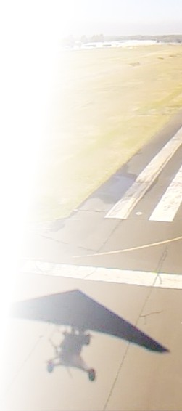
Readers Pictures
8,500 feet over Mount Bogong, Pilot Steve Bell, Photographer Ian Rees.
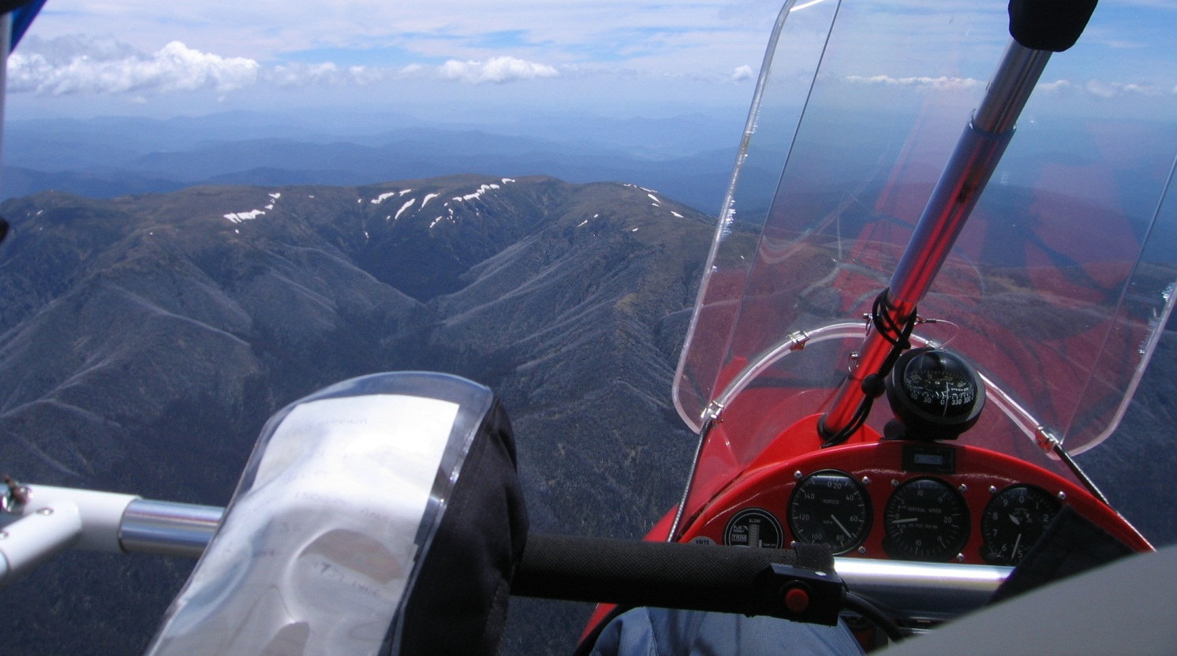

Contributions
Please send all contributions to newsletter@southernmicrolightclub.com.au
We are looking for
- Pictures
- Articles
- Tip of the month
- Items for sale
- Trike related humour
- Trike friendly airfields
- Scenic routes
- Maintenance tips
Do not concern yourself over making it look pretty or grammatical correctness. We are a Trike club, not a literary society. We just want to hear about the escapades of our members.
Please take care however about tips and tricks. Please ensure correctness and include sources. The whole idea is that our members can rely on the information given to be factually correct.

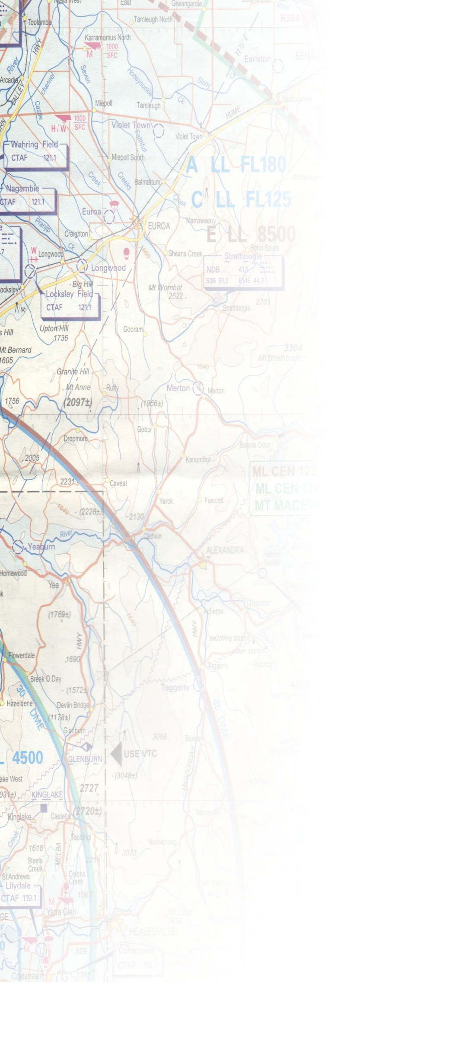
Upcoming Event, Locksley Field
2nd and 3rd February 2013
Locksley Field isn’t a new venue for us. It is a venue that is easily reached by air for many and for the rest; there is plenty of space to park trailers. With a 1.9km grass runway, and huge open spaces all around, this is the place to be if you want to practice forced landings. Needless to say it also sports some fantastic fly-aways. The Cathedral Ranges are a stone’s throw away, as is Lake Eildon, and let’s not forget, if you need something from the pilot shop, there is also Yarrawonga in the other direction.

Airfield Data
ALA Code: | YCLS
GPS Position: | 36⁰ 48.850’ South 145⁰ 20.940’ East
GPS Decimal: | -36.81502 145.34835
Elevation: | 540 Feet AMSL
Area Forecast: | 30
Strip Directions: | 01-19 1880 metres 11-29 Closed
CTAF: | 121.1

This Airfield is close to Mangalore which is a very busy aerodrome. Look, Listen and Avoid.

Eating Arrangements:
Self-catering. There are cooking facilities on site in the form of a small kitchenette; however cutlery and crockery will be limited, it is advisable to bring your own. Alternatively you can try Thyme & Place Restaurant and Bar in Avenel (03) 5796 2688 about 20km distance

Sleeping Arrangements
There is a campsite and space for caravans. You can also bring your swag and sleep under your wing. The choice is yours.

Fuel
Fuel is available at Caltex Avenel. (Hume Highway, Avenel, VIC) about 20km distance

Fees
There will be fees associated with this event. They will however be relatively insignificant. People flying in for the day should expect to pay minimal landing fees and people camping should expect to pay their camping fees.

Contact
If you would like more information about this event as it arises, please send an email to : trevor@teknological.com.au
If you may come but do not want to commit please send an email to: iwouldliketoattendbutitisweatherdependent@teknological.com.au

Pilot Information Evening
Based on a true story by Trevor Lane
T
here was no way I was going to miss the opportunity for me to see the inner workings of Air Traffic Control. I have a great respect for air traffic controllers and even once thought I might like to do that job myself. That is right up until I realized that being deaf wasn’t going to help and also I wasn’t sure about my mental capacity since seeing the film “Pushing Tin” in 1999.
“By the time Joe had gone through the process and joined me, I was curled up on the floor in the foetal position rocking gently backwards and forwards”
Dean had done a great job, making sure I knew where to present myself and sending me emails and text messages reminding me to take photo ID and informing me of the time it takes to get the security clearance required in order to get into the compound. Without his organisational skills I would have gone to the airport terminal and asked a policeman “how do I get to the Tower?” I would have probably spent some time in a cell and missed the whole thing if I had been left to my own devices. I imagine Dean knew this, and also knew he would have been having phone calls late into the night asking him to post bail if he screwed up, so it was probably in his own interest to make sure I wasn’t left to do my own thing.

So I decided to put the address into my GPS and let “Sam” as she is affectionately known by me, to do the rest. Well she was going to take me around the M80, but I knew a shortcut. “Sam” adjusted the route when I deviated and sent me over Donnybrook which was always going to be my intention anyway. But I do have to say, I really needed her to help me navigate the final few kilometres around lord knows where, to get to the Airservices building. Joe was already at the gate when I pulled up behind him, I knew it was Joe because he had his driver’s side window down as did I, and I could hear his favourite oompha band playing on his car stereo. The security box was unmanned and there was little clue how to get in. I joined Joe in the search for the elusive button that was going to put us in contact with someone to open the gate. We found it, waved at the camera which turned to look at us; and announced our intentions. “AirServices Australia this is two members of the Southern Microlight Club stationary at the gate intending to attend a pilot briefing night; AirServices.”. “Two pilots at the gate, you are cleared to taxi to the first car park on the left and enter through the doors marked KEEP OUT, YOUR LIFE MIGHT DEPEND ON IT”. (poetic licence applied for). We both returned to our vehicles and waited for the gate to open. Joe went through and I closely followed until the gate shut before I could clear it. What happened there? I had to go through the whole process again.

We entered the building and walked directly to the reception desk on our right. A security guard greeted us warmly and made sure I could see her gun. I smiled nicely and made sure she knew I was going to do exactly as I was told. “Good evening, can I have your driving licence please?”, “yes of course, you can have my car as well if you like! Ma’am”. I had managed to get through the process of confirming my identity and making sure she was happy that I didn’t pose a threat, and she had given me a visitors badge. Not just a visitors badge at that, it was an “accompanied visitors badge”. “Please wait over there to be taken through!” “Yes, of course ma’am, whatever you say ma’am”.
“I would have probably spent some time in a cell and missed the whole thing if I had been left to my own devices.”
By the time Joe had gone through the process and joined me, I was curled up on the floor in the foetal position rocking gently backwards and forwards. It wasn’t long before the others arrived; that is all of the others barring George; and I was feeling comfortable again being in a large group. George isn’t always late it just seems that way. What you have to understand is that George holds down two jobs in order to fund his extravagant life-style and so it is amazing that he sometimes manages to turn up at all.
We were eventually met by a delightful young lady who was going to be one of our hosts for the night. She took us to a conference room where we were introduced to [name not remembered] who was going to give us a brief on what Airservices actually did. Namenot had just come back from long service leave and had to remind himself of what exactly it was that Airservices did, so he may as well give us the briefing at the same time. He had prepared a complete presentation aimed at GA pilots when it dawned on him that we were a Microlight club. Our wait to be brought through had been taken up with Namenot changing his presentation to be geared more towards the sports aviators that we are. I was impressed that they took the trouble to do that.
We sat through an excellent presentation about the role of Airservices, what they are, and what they are not. It is now perfectly clear in my mind that what they do, they do; what they do not do, they do not do. What they do is not what they do not do; and what they do not do, is not what they do. If you really want to know what all of that is, then you really should put your name down for an evening with them. I imagine the club will organise another trip when there is sufficient new members and interest. Suffice it to say, it is better coming from their own lips than relying on the memory of a fifty-something year old fart.
The question and answer session at the end was also entertaining. I am not sure it was supposed to be entertaining, but more-so informative; however it really does rely on the quality of the questions.
“How low can a Boeing 747 go?” asked anonymous; “At times the wheels touch the ground” replied Namenot.
“Do you have a taser so you can put rogue ATC controllers down?” asked anonymous; No reply was forthcoming but lots of tears and side-splitting laughter.

Eventually Namenot managed to get up off the floor where he had been rolling around laughing. “I think it’s time we visited the control room” he said, then he led us up the stairs to ATC proper. No Unauthorized Weapons read the sign on the door, and we were asked to not be too disruptive whilst we were in there. “And please don’t ask any more stupid questions, the guys cannot see the screens if they are crying and it gets difficult to talk to the pilots requesting information if you cannot breathe”. Fair enough I thought and I remembered the posters I saw in the staff canteen reminding them that it isn’t always good to have a sense of humour. I suppose playing cricket using a 747 as the bat and a Cessna as the ball is probably not. Cricket that is.
Talk about information overload. Each controller has five computer monitors set up in a purpose built console giving them the information needed to keep the skies safe. At the end of each aisle there is a clock on the wall showing time in UTC which is a constant reminder of the size of the area that they control. UTC is standard as we all know when talking to ATC but it makes you realize that this one control room in Melbourne is responsible for a huge amount of sky, crossing more than a few time-zones. In fact Airservices, in two control rooms (Melbourne and Brisbane) control 11% of the world’s skies. That’s phenomenal. They take their work seriously. The control room is so well thought out, it is not so comfortable as to induce sleep, but it is comfortable enough not to cause a distraction from any discomfort. Even the lights have been designed not to cast any shadows. Glare has been eliminated from the computer terminals, and tea and biscuits are close enough to not lose sight of your console if you need refreshment, but not so close as to cause gluttony, or to distract you from your work
We were eventually asked to leave, but reconvened in the training facility. We didn’t have to be so quiet and unobtrusive in there and a training exercise had been set up so that the screens were actually showing something to keep us occupied. This is where we could get excited if we felt like it, sadly no-one felt like it, apart from me. “You should pass that aircraft on to the next controller” I said pointing to a blip on the screen that changed colour. “Oh yes” said the instructor and with a click of the mouse it had been done. The instructor turned around again to tell us about some other interesting part of the job when I interrupted again. “That aircraft has just entered your sector and you were too busy to notice, shame on you”. “Hey look clever clogs it isn’t real you know, I was talking”. “That’s not the attitude” I said, then remembered the security guard on the door with the gun. That probably isn’t the attitude I thought and shut up.
“We were asked to not be too disruptive whilst we were in there”
The evening was drawing to a close and we all went back down to the conference room for tea, biscuits and a last minute informal Q&A session. Needless to say George had to rush away. He was looking forward to three hours sleep before he had to be back at work. The rest of us could afford to be a little more relaxed.
I am so pleased I took the opportunity to see the facilities they have. It is well worth the time that you have to give to it. I would heartily recommend any pilot go. It isn’t just for the spam cans; it is a great experience for everyone.

A Christmas Wish
Graham Keen
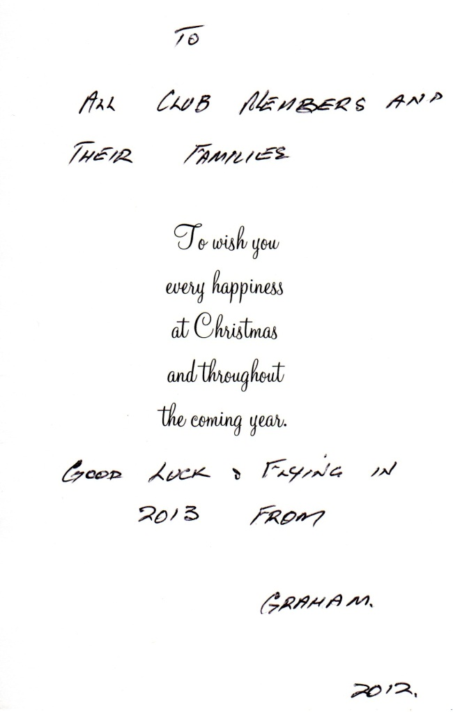

Southern Microlight Club Incorporated
Useful Information
Southern Microlight Club Inc. is incorporated under the Associations Incorporation Reform Act 2012
Southern Microlight Club Inc. is affiliated to the Hang Gliding Federation of Australia
If you would like to pay money into the club account for payment of membership fees, the purchase of polo shirts, or deposits for events; then please make a direct deposit to:
Account Name : Southern Microlight Club
BSB : 063109
Account No : 10405908
Please indicate your name and what you are paying for. If you do not have enough space in your banking website to put sufficient information, then please email treasurer@southernmicrolightclub.com.au with the details.

